Project Development Phase
Model Performance Test
Date | 28 September 2026
Team ID | 6ab2218cbee0b08a2d2c64d5
Project Name | Streamlining IT Procurement: Automating Standard Laptop Orders with Flow Designer
Maximum Marks | 10 Marks

Model Performance Testing:
Project team shall fill the following information in model performance testing template.
S.No. | Parameter | Screenshot / Values
1. | Data Rendered | Data rendered on the Requested Item / Catalog Task form fields (Short Description, Assignment Group, Approval) as populated by the flow  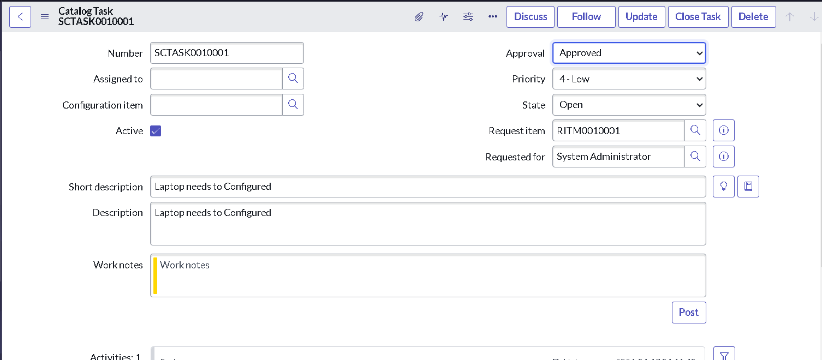
2. | Data Preprocessing | Not required - the flow reads the Requested Item record directly and maps fields without additional preprocessing  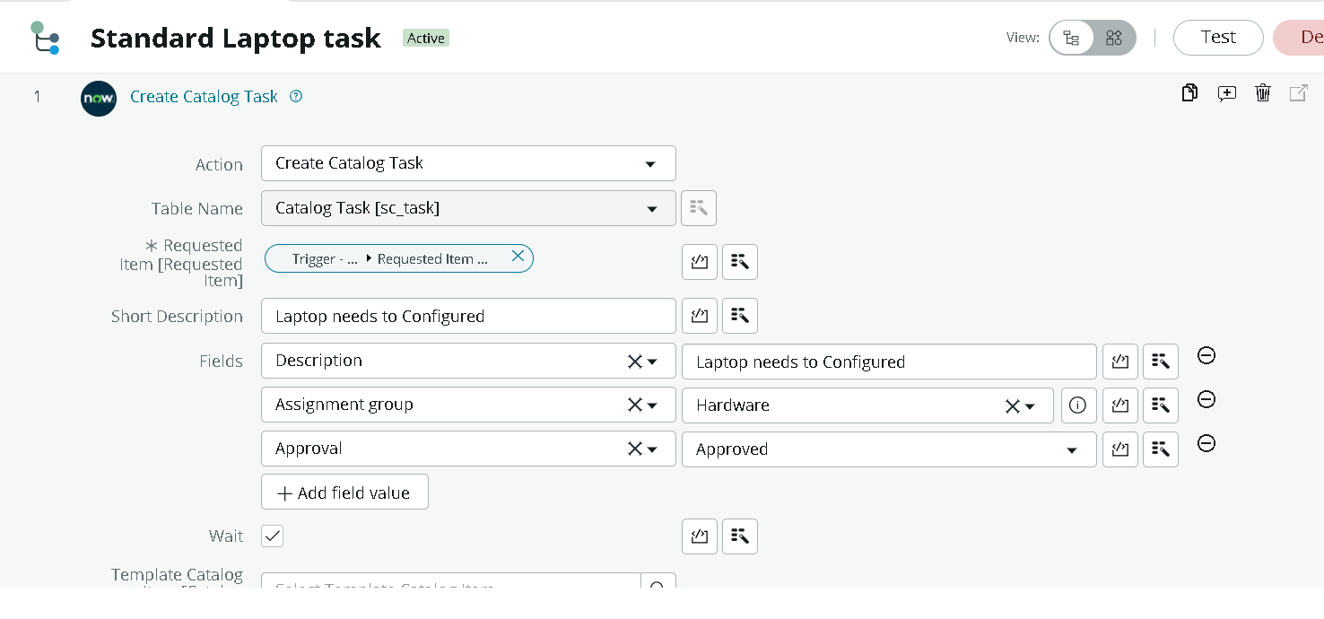
3. | Utilization of Data Filters | Trigger filter condition set on the 'Service Catalog' event to fire only for the 'Standard Laptop' catalog item  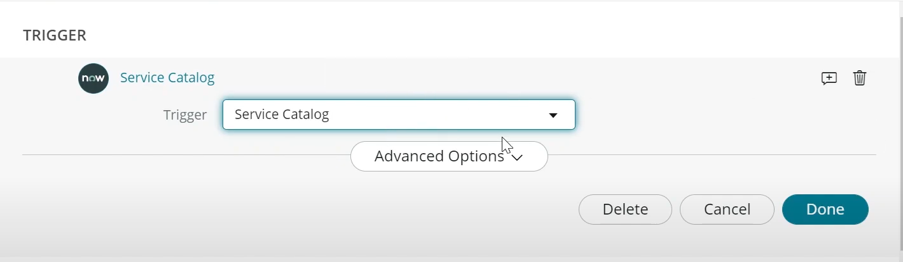
4. | DAX Queries Used | Not Applicable - no DAX queries used; logic is implemented via Flow Designer actions instead of Power BI DAX
5. | Dashboard design | No of Visualizations / Graphs - Not Applicable for this ServiceNow automation project (no Power BI dashboard was built); flow status is monitored via Flow Designer execution logs
6. | Report Design | No of Visualizations / Graphs - Not Applicable for this project

